VIDHYA.R

192572153

SIMATS ENGINEERING

ASSESSMENT TOOL 3

COURSE NAME: Artificial Intelligence COURSE CODE: CSA1715

COURSE OUTCOME COVERED

CO1: Apply AI basics such as intelligent agents and uninformed search methods to solve problems effectively. (BL3)

Assessment Tool Weightage: 10%

Duration : 30 Minutes
QUESTIONS: 2 Total Marks:20

Annexure A

Descriptive Written Test

Code of Conduct:

I VIDHYA.R (192572153) certify that this submission is my original work and that I have adhered to the guidelines specified for this assessment.
I understand that any violation of academic integrity rules will result in disciplinary action.

Signature of the student:



Annexure A

Descriptive Written Test

- A smart home automation system is being designed to manage lighting, temperature, and security based on user behavior and environmental conditions. The system must respond to real-time inputs such as motion detection, temperature changes, and time of day while also learning user preferences over time. In this context, explain the different types of intelligent agents (simple reflex, model-based, goal-based, and utility-based agents) and analyze how each type would function within this system. Justify which type of agent or hybrid approach would be most effective for ensuring comfort, energy efficiency, and security.

- A robot is placed in an unknown maze and must find a path to the exit without prior knowledge of the layout. Explain how uninformed search strategies like Uniform Cost Search (UCS) and Iterative Deepening Search (IDS) can help solve this problem.
Discuss the advantages and disadvantages of these algorithms in terms of time and space complexity. Relate the problem to different types of intelligent agents and explain how agent design affects decision-making. Suggest which combination of agent type and search strategy would be most effective and justify your choice.

RUBRICS FOR CALCULATION:

Criteria | Weightage | Level 4 – Exemplary | Level 3 – Proficient | Level 2 – Developing | Level 1 – Beginnin g
Criteria | Level 4 (Exemplary) | Level 3 (Proficient) | Level 2 (Developing) | Level 1 (Beginning) | Max Marks
Understanding of Concepts | 25% | Demonstrates thorough, accurate understanding of concepts | Good understanding with minor gaps | Basic understanding with some misconception s | Poor understandi ng; major misconcepti ons
Explanation | 25% | Detailed,  well-explained answers with relevant examples | Clear explanation with adequate details | Limited explanation; lacks depth | Poor or unclear explanation
Application | 20% | Effectively applies concepts with strong analytical ability | Applies concepts with minor errors | Limited application with weak analysis | No application or incorrect analysis
Organization | 15% | Well-structure d answers with logical flow and coherence | Organized with minor issues in flow | Basic structure, lacks clarity | Poor organizatio n, incoherent answers
Accuracy | 10% | Completely accurate and covers all required points | Mostly accurate with minor omissions | Partially correct with missing points | Incorrect answers with major gaps
Clarity | 5% | Clear, neat, professional presentation | Understandable with minor issues | Limited clarity, readability issues | Poorly written, difficult to understan d
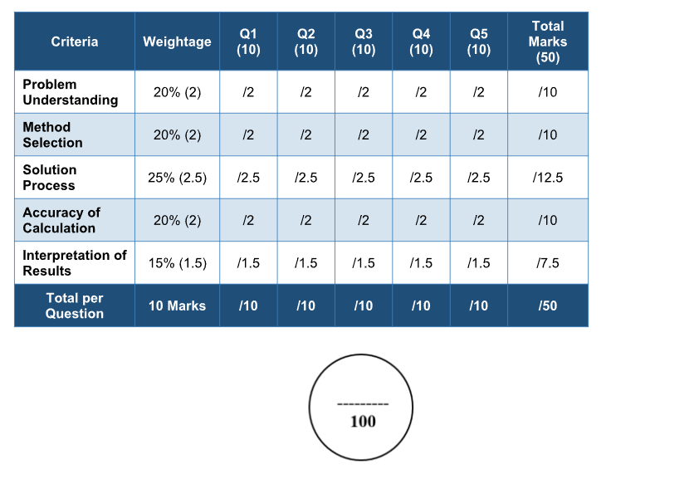
ANSWERS:

- Simple Reflex Agent

A Simple Reflex Agent makes decisions only on the basis of the current percept (current input). It follows predefined condition-action rules and does not remember previous events or maintain any history.

Working in the Smart Home:

- If motion is detected in a room, the agent switches on the lights.
- If no motion is detected for a specific period, the lights are turned off.
- If the room temperature exceeds 30°C, the air conditioner is switched on.
- If smoke is detected, the fire alarm is activated immediately.

Advantages:

- Very fast response.
- Easy to design and implement.
- Requires very little memory.
- Suitable for simple automation tasks
.
Disadvantages:

- Cannot remember previous events.
- Cannot learn user habits.
- Fails in partially observable environments.
- May make poor decisions if the current input is incomplete.

Example: Every evening at 6 PM the porch light turns on automatically because of a predefined rule.

- Model-Based Reflex Agent

A Model-Based Agent improves upon the Simple Reflex Agent by maintaining an internal model of the environment. It remembers previous states and uses that information while making decisions.

Working in the Smart Home:

- Remembers which rooms were occupied recently.
- Keeps track of whether doors and windows are open or closed.
- Detects whether the homeowner is inside or outside the house.
- Uses previous sensor readings to predict future actions.

Advantages:

- Can work in partially observable environments.
- Maintains memory of previous events.
- Makes more intelligent decisions.
- Reduces unnecessary actions.

Disadvantages:

- Requires additional memory.
- More computationally expensive.
- Internal model must be updated continuously.

Example: Even if motion temporarily stops because the user is sitting quietly, the lights remain on because the agent remembers the room is occupied.

